Studland Bay Access Statement

Knoll Beach, Ferry Road, Studland, Dorset. BH19 3AQ
T: 01929 450500
E: studlandbay@nationaltrust.org.uk

Introduction

A glorious slice of natural coastline in Purbeck featuring a four-mile stretch of golden, sandy beach, with gently shelving bathing waters and views of Old Harry Rocks and the Isle of Wight. Ideal for water sports and includes the most popular naturist beach in Britain. The heathland behind the beach is a haven for native wildlife and features all six British reptiles.

There are designated trails through the sand dunes and woodlands, which allows for exploration and spotting of deer, insects, reptiles and bird life as well as a wealth of wildflowers. Access along many of our paths for the less able or wheelchair users is difficult due to uneven surfaces; sand and woodland.

Dogs are welcome all year but must be on a short lead (under 2m) on the beach from the 1 May to 30 September. Cattle graze on the heathland so please be alert to this and put dogs on a lead in these areas. Dogs are allowed in the Knoll Beach Shop but not in Knoll Beach Café. Assistance dogs are welcome in all areas. Water bowls are located around the Knoll Beach Centre.

We have beach accessible wheelchairs (4 self-propelled and 1 electric) available from Knoll Beach Visitor Reception, which can be hired free of charge (non-monetary deposit requested). Booking is recommended.

A Tramper (an all-terrain mobility scooter specially designed for exploring the countryside) is available and can be hired to take the route from South Beach car park (BH19 3AU) to Old Harry Rocks. The person using the Tramper must be a member of Countryside Mobility. You can join at Studland prior to the Tramper hire. Booking is essential.

Deckchairs and sun loungers can be hired during the summer from Studland Watersports at Knoll Beach.

Staff and volunteers wear branded National Trust clothing (usually black or grey) with a name badge and will be happy to help you, please ask.

Knoll Beach car park is open 7 days a week, 365 days a year, parking charges apply every day 8am – 8pm. The café and shop are open every day, (except 25 December). It is advisable to check details about the café and shop opening times, facilities and events via our website: www.nationaltrust.org.uk/studland-bay, Facebook or 01929 450500.

Arrival & Parking Facilities

- The main car park for Studland is at Knoll Beach (BH19 3AQ), accessible from Ferry Road. There are brown tourism signs that mark the entrance to the car park and one green threshold sign.
- The entrance driveway is tarmac, it slopes down to the beach and a parking area which it is compacted stone.
- There are speed restrictions of 5mph and speed bumps in all Studland car parks.
- There is a designated area for disabled persons and those with mobility difficulties to park at Knoll Beach.
  - This area is signposted and can be found by taking the 2nd left into the main car park, drive to the far end of the car park, turn right towards the beach huts and enter a smaller section of the car park.
  - Look for the disabled signage on the car park surface in each designated disabled space. The surface in this area is compacted stone.
  - There are 20 marked disabled spaces and 14 larger spaces along the same stretch of car park.
  - From these parking spaces there is a solid block pathway to the café, shop and toilets, approximately 50 metres.

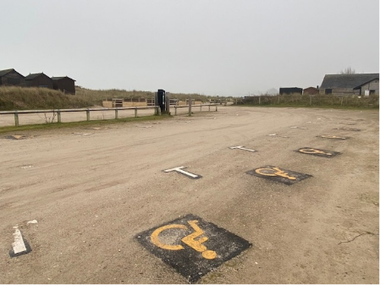
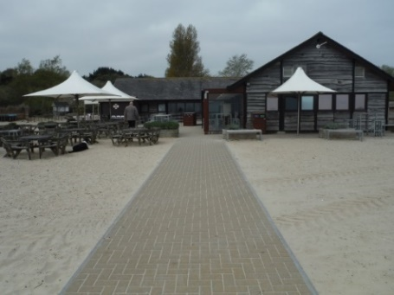

Disabled parking area Pathway from car park to Café and Shop

- There is a drop off point at the bottom of the car park, in the turning circle area marked in yellow with disabled signage on the car park surface. This surface is tarmac. There is a walkway from this drop off point that will lead you to our Visitor Reception, cafe, shop and toilets. The walkway is initially wooden and connects to a brick path.

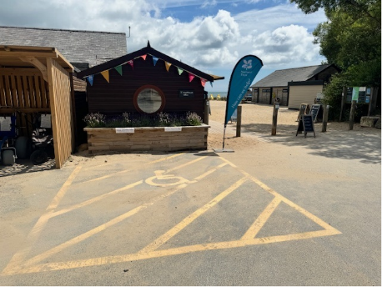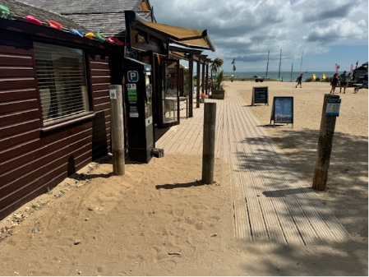

Drop off point outside Visitor Reception Boardwalk from drop off point

- Parking is free for Blue Badge holders. Please display your badge.
- Parking is via parking machines for those without a Blue Badge and there is a parking machine located near the parking area.
- The parking machines take coins and card, alternatively use the JustPark parking app . Location code for cars 998930.
- Prices are shown next to the machine.
- Parking is free for National Trust members (scan your member card at the machine or on the JustPark app to gain a free parking ticket).
- If you are interested in joining the National Trust, please visit our website https://www.nationaltrust.org.uk/membership or speak to one of the team at the Visitor Reception before you pay to park.

- Please be aware that during busy times the car park can become full as early as 10am and the overflow car park is not as accessible as the main car park. There is at least 0.5 mile walk from the overflow car park to Knoll beach over mixed terrain and along a road which will take at least 15 minutes.
- To give you the best chance of a parking space we would recommend arriving before 10am or after 2pm on hot sunny days during school holidays.
- When Knoll car park is full, please park at Middle (BH19 3AQ) or South Beach (BH19 3AU) car parks and try Knoll Beach car park again later in the day.

Toilets

Accessible toilet

- There is a left-hand transfer wheelchair accessible toilet at Knoll Beach close to the café and shop.
- This is accessed up a ramp and can be opened with a RADAR key during the hours our car park is open.
- All toilets have automatic hand driers, tiled floors with natural and halogen lights.
- RADAR keys are available from the Visitor Reception, next to the shop entrance.
- An alarm is not fitted to this toilet.
- Please note our self-propelled wheelchairs do not fit into the disabled toilet at Knoll Beach.

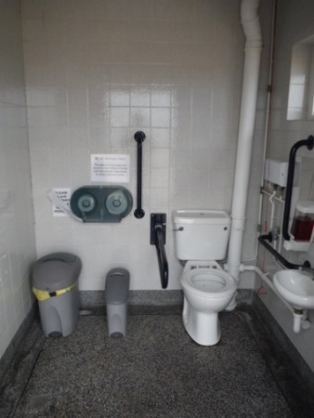

Knoll Beach Accessible Toilet

Changing Places Toilet
There is a Changing Places Toilet at Knoll Beach next to the café and shop. This can be opened during the Visitor Reception opening hours (core hours 9am – 4.30pm) with a RADAR key and additional key which is used for security reasons and can be collected from Visitor Reception.
This toilet has:
- A height adjustable bench, adult sized, wall mounted
- Hoist - Ceiling, Loop
- Peninsular Toilet
- Washbasin Height Adjustable
- Non-Slip Floor
- Floor Space (sq. m) - 16.7
- Emergency Alarm
- Privacy Screen
- Paper Roll
- Accessible Shower
- Colostomy Shelf
- Unisex
- Signage in the room
- Drop down grab rails
- Wall grab rails
- Large Bin
- Door Width (m) - 1.00
- Ceiling height (m) - 2.40

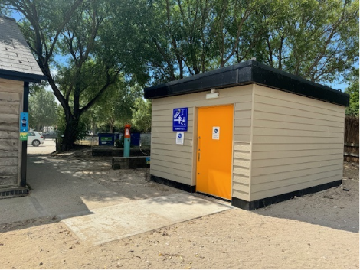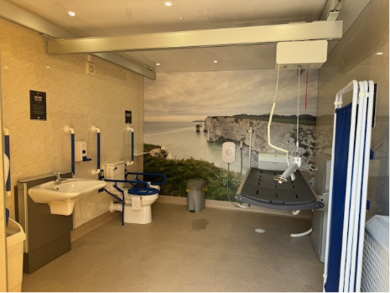

External and internal of the Changing Places Toilet at Knoll Beach

Visitor Reception

The Visitor Reception at Knoll beach is based in a wooden hut which is accessible from the turning circle at Knoll Beach via a wooden boardwalk.

Other than parking, Studland Beach is free to access, and you can find out about the local area and the work of the National Trust here.

For more information and bookings please email studlandbay@nationaltrust.org.uk or call 01929 450500.

- The office can be accessed over a wooden boardwalk that leads into the building.
- The floor in this building is level concrete covered in non-slip vinyl and the wall surfaces are wood panelled.
- One half side of the building is glazed with doors that have a width of 170cm and the lighting is LED.
- The reception desk is 110cm high.
- A doorway into a similar sized room is 96cm wide and has a desk 75cm high.
- Seats are available in the office.
- A hearing loop is fitted.

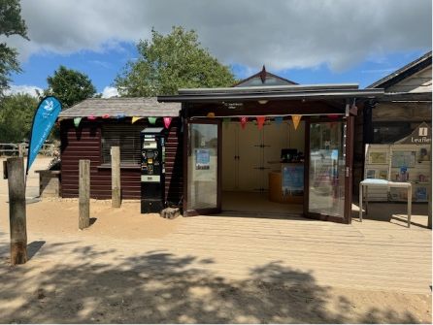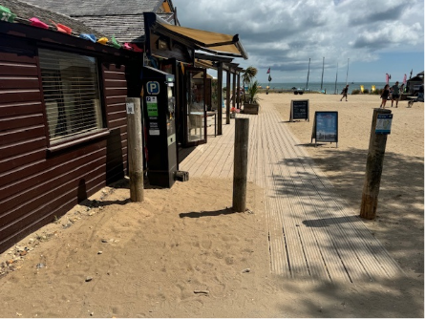

Knoll Beach Visitor Reception and boardwalk

Wheelchair hire

- We have 4 all-terrain beach accessible wheelchairs and 1 Magic Mobility Xtreme 8 Electric wheelchair available at Knoll Beach.
- Can be hired free of charge (non-monetary deposit requested) from Visitor Reception.
- These wheelchairs must not go in the sea/water.
- Training will be provided.
- Booking recommended.
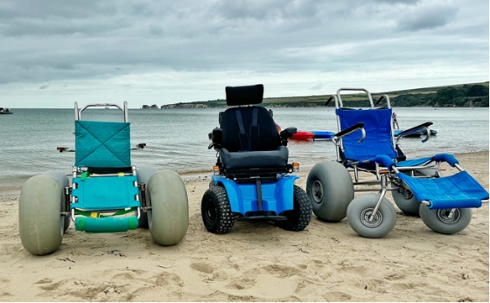
2 all-terrain beach wheelchairs and 1 Magic Mobility Xtreme 8 Electric wheelchair

Tramper hire

- A Tramper is available to hire from South Beach car park (BH19 3AU) with a designated linear route that will take you to Old Harry Rocks.
- The Tramper must not be used on sand.
- For more information, please visit Countryside Mobility https://countrysidemobility.org/.
- You will need to be a member of Countryside Mobility to use the Tramper.
  - One off use £3
  - 2 week taster £5
  - Annual membership £15.
- Team members can join you upon arrival.
- If you are already a member of Countryside Mobility please bring your membership card with you.
- Training will be provided.
- Booking essential.

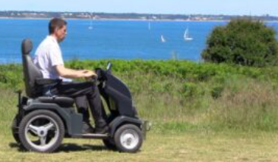

Tramper on route to Old Harry Rocks

Sensory Bags

We have 2 sensory bags available to borrow free of charge from our Visitor Reception (non-monetary deposit required). Please speak to one of the team.

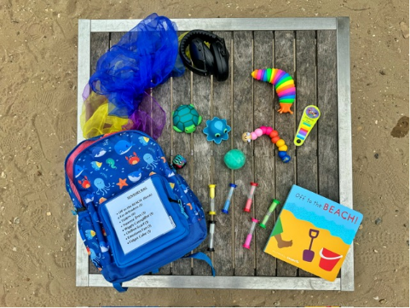

Example of what to expect in one of the sensory back packs

Easier Access Beach Hut

- We have a beach hut at Knoll Beach that can be booked in advance on a daily basis and is designated for those who need easier access.
- The beach hut has a designated parking space behind it.
- Booking essential. The beach hut will be offered to all visitors if it has not been pre-booked and is available on the day.

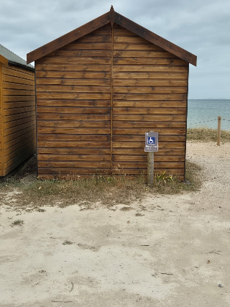

Front and back of Blue Badge beach hut

Food & Beverage

Knoll Beach Café

The cafe is in the Knoll Beach Centre, which can be accessed from the patio and brick pathway from the car parking area for disabled visitors.

- The doorway is 88cm wide and is up a ramp approx. 5% gradient and 1.5 metres long. The glazed door is usually open to at least 90 degrees and is non-power assisted. The door opens outwards. Food & Beverage team members can assist if required.
- The counter is 90cm high. F&B team members are available to assist with service and carrying trays.
- A hearing loop is fitted.
- The width between the tables varies.
- If you find difficulty in queuing for counter service, table service is available on request.
- Straws, Veg ware cups and 2 handled china cups are available.
- The floor is concrete covered in non-slip vinyl, wall surfaces are wood panelled, and the lighting is LED. The chairs are wooden and have backs with no arms and there is a seating area beside the log burner that has sofa and armchair seating.

- The café serves hot and cold drinks and a selection of hot and cold food.
- Please make a team member aware of any allergies or intolerances and they will assist with what is available to you.

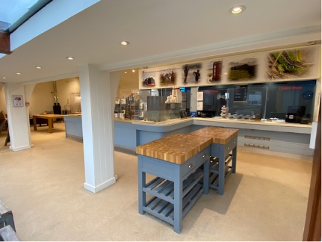
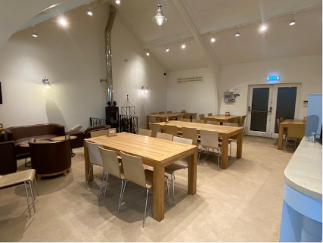

Knoll Beach Café Interior

Retail

Knoll Beach Shop

The shop is in the same building as the cafe and can be accessed through the café seating area.

- There is a separate doorway to the shop which is 88cm wide and is up a non-slip decked ramp approx. 3% gradient. The glazed door is usually open to at least 90 degrees and is non-power assisted. The door opens outwards. Retail team members can assist if required.
- The floor is concrete covered in non-slip vinyl, wall surfaces are wood panelled, and the lighting is LED. There is currently a small threshold strip at the entrance.
- The counter is 90cm high, but staff will assist with lifting and carrying goods if required.
- An induction loop is fitted.
- There is circulation space between the display tables of around 100cm and some of the goods on the central tables can be easily reached by all. Retail team members can assist if required.
- The shop sells a selection of beach goods, souvenirs and gifts.

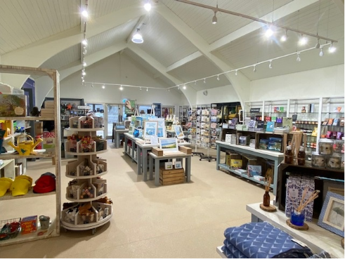

Knoll Beach Shop Interior
For more information:
T: 01929 450500
E: studlandbay@nationaltrust.org.uk

August 2026

