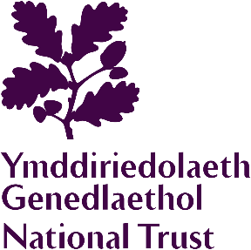
Chirk Castle and Garden
Educational Group
Booking Form

GROUP INFORMATION
School/group name
Date of visit |  |  | Number of coaches
Arrival time |  |  | Departure time
Education Group Membership Number
Number of children  (0-11 years) | Number of Young people  (12-25 years) |  |  | Number of adults (26+ years)
It is the responsibility of school/education groups to ensure they have public liability insurance with a £5m indemnity limit in place when they visit. Requesting a visit via this form confirms your school/group has this insurance in place. This doesn’t apply to home-educating families when parents are visiting solely with their own children.
Special interests

Special requirements (e.g. wheelchair)

GROUP CONTACT
First Name |  | Surname
School/group address

Email
Telephone
PAYMENT
Method of payment (please mark ‘X’ where applicable)

Company Invoice Credit Card Cash
(Existing National Trust
credit account holders only)

On arrival, please arrange for one person to check in at the Ticket Office and make payment for the group in one transaction. We no longer accept cheques. Companies wishing to pay by Invoice must liaise with the Property Administration office. We are unable to accept Credit Card payments by phone.
DATA PROTECTION
We are collecting your contact information for the purposes of this group booking only and will not use the information you provide for anything else. Your privacy is important to us, so we’ll always keep your details secure and never use them for marketing communications that you haven’t agreed to receive. "We" means the National Trust, charity number 205846, and National Trust (Enterprises) Limited.

Once completed, please return this form to: chirkcastle@nationaltrust.org.uk

