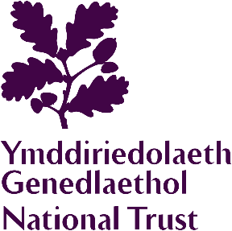

Educational Group
Booking Form

GROUP INFORMATION
School/group name
Date of visit | Number of coaches
Arrival time | Departure time
Education Group Membership Number
Number of adults |  | Number of children
Number of National Trust members in group
Please collect and present the Membership Cards together when checking in.
Special interests

Please indicate if your group will be using the Tearoom (please mark ‘X’ if applicable)

Morning coffee Lunch Afternoon Tea
Special requirements (e.g. wheelchair)

GROUP CONTACT
First Name |  | Surname
School/group address

Email
Telephone

PAYMENT
Method of payment (please mark ‘X’ where applicable)

Company Invoice Credit Card Cash

On arrival, please arrange for one person to check in at the Ticket Office and make payment for the group in one transaction. We no longer accept cheques. Companies wishing to pay by Invoice must liaise with the Property Administration office. Cheques payments should be made 2 weeks in advance and made payable to the National Trust. We are unable to accept Credit Card payments by phone.
DATA PROTECTION
We are collecting your contact information for the purposes of this group booking only and will not use the information you provide for anything else. Your privacy is important to us, so we’ll always keep your details secure and never use them for marketing communications that you haven’t agreed to receive. "We" means the National Trust, charity number 205846, and National Trust (Enterprises) Limited.

Once completed, please return this form to: chirkcastle@nationaltrust.org.uk

