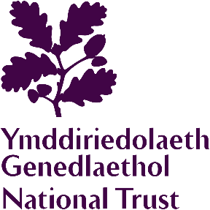

Chirk Castle and Garden
Group Booking Form

GROUP INFORMATION
Group/company name
Date of visit | Number of coaches
Arrival time | Departure time
Nationality of group
Number of adults |  | Number of children
Number of National Trust members in group
Please collect and present the Membership Cards together when checking in.
Special interests

Special requirements (e.g. wheelchair)

GROUP CONTACT
First Name |  | Surname
Address

Email
Telephone

Once completed, please return this form to: chirkcastle@nationaltrust.org.uk

PAYMENT
Method of payment (please mark ‘X’ where applicable)

Company Invoice Credit Card Cash
(Existing National Trust
credit account holders only)

On arrival, please arrange for one person to check in at the Ticket Office and make payment for the group in one transaction. We no longer accept cheques. Companies wishing to pay by Invoice must liaise with the Property Administration office. Cheques payments should be made 2 weeks in advance and made payable to the National Trust. We are unable to accept Credit Card payments by phone.
We are collecting your contact information for the purposes of this group booking only and will not use the information you provide for anything else. Your privacy is important to us, so we’ll always keep your details secure and never use them for marketing communications that you haven’t agreed to receive. "We" means the National Trust, charity number 205846, and National Trust (Enterprises) Limited.

Once completed, please return this form to: erddig@nationaltrust.org.uk

